Food Tech

Now-a-days maximum peoples are ordering food by using online services and this online services are dependent on single centralized server and if this server crashed due to overload request or if hacker hack this server then online food services will stop working. To overcome from this problem we are migrating food deliver application to Blockchain server which will maintain data in decentralized (multiple nodes/servers will maintain data) manner and Blockchain store each data as block/transaction and associate each transaction with unique hash code and this hash code will get verified upon storing new block and this block cannot be modified and due to hash code verification no hackers can attack the server and if one Blockchain server down then application will use services from other working nodes, so by migrating application to Blockchain server we can get services from any working node and can prevent servers from getting hacked.

To store each data as Blockchain transaction we are using below code

Below screen showing Blockchain code to store data with proof of work and hashcode

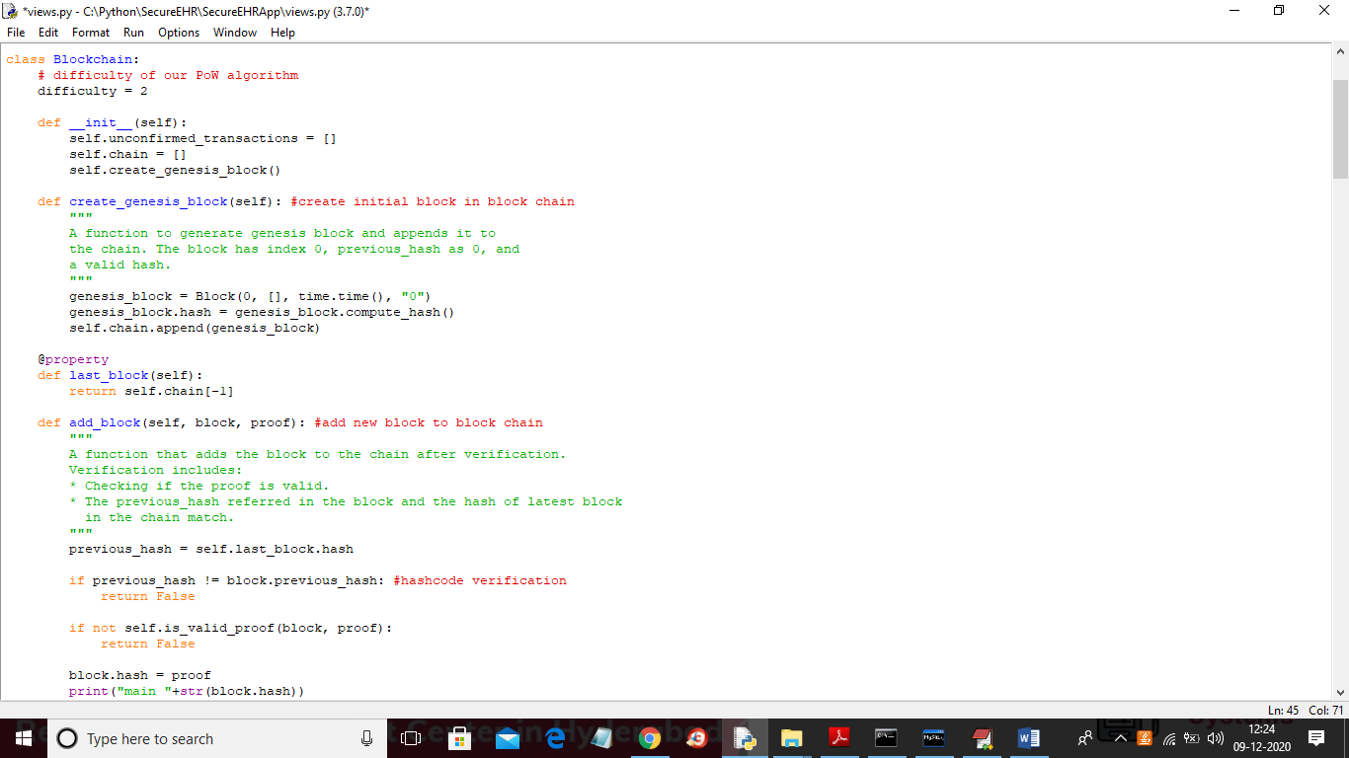

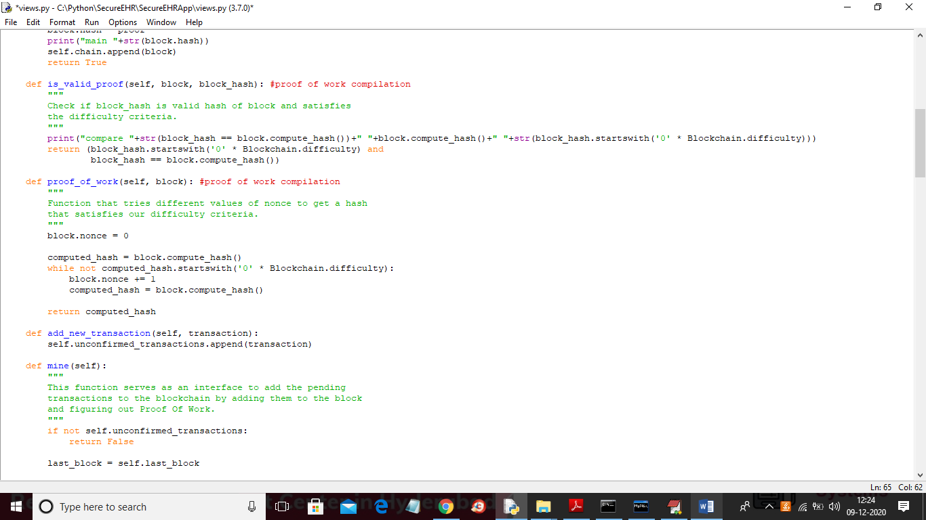

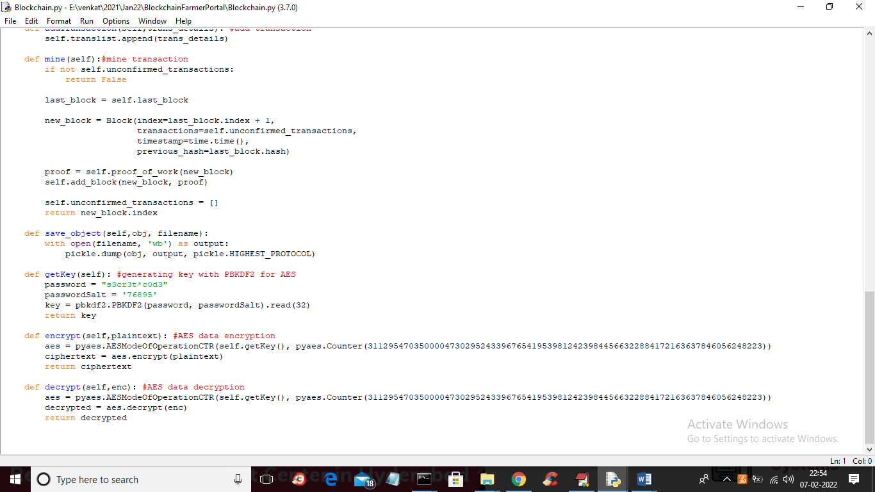

In above 3 screens you can read red and green colour comments to know how Blockchain encrypt data and then store that in blocks with hashcode and then perform proof of work for block verification.

To implement this project we have designed following modules

1. Admin: admin can login to application by using username and password as admin and then can add new food details and store in Blockchain and can view orders from customers
2. User: user can signup with the application and can browse food and book the food for delivery

SCREEN SHOTS

To run project double click on ‘run.bat’ file to start DJANGO server and then open browser and enter URL as <http://127.0.0.1:8000/index.html> and press enter key to get below page

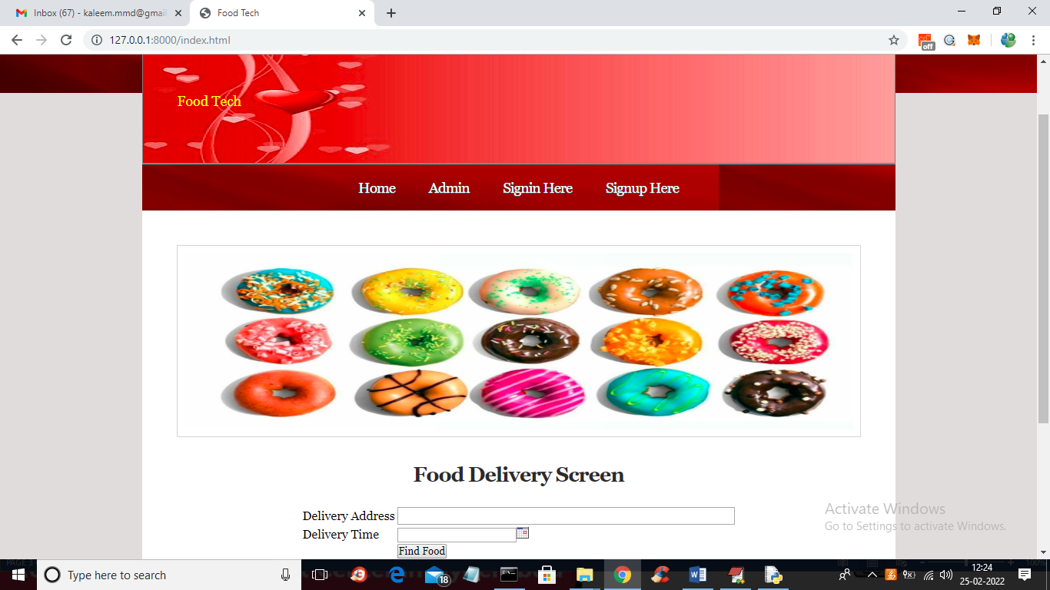

In above screen click on ‘Signup Here’ link to register with the application

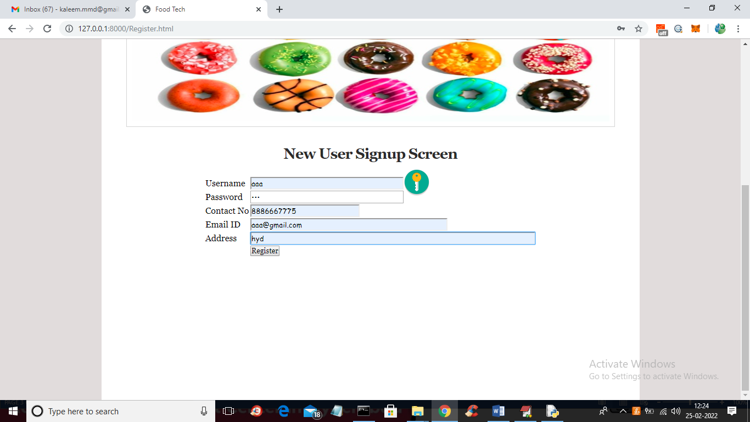

In above screen user is entering signup details and then press button to get below output

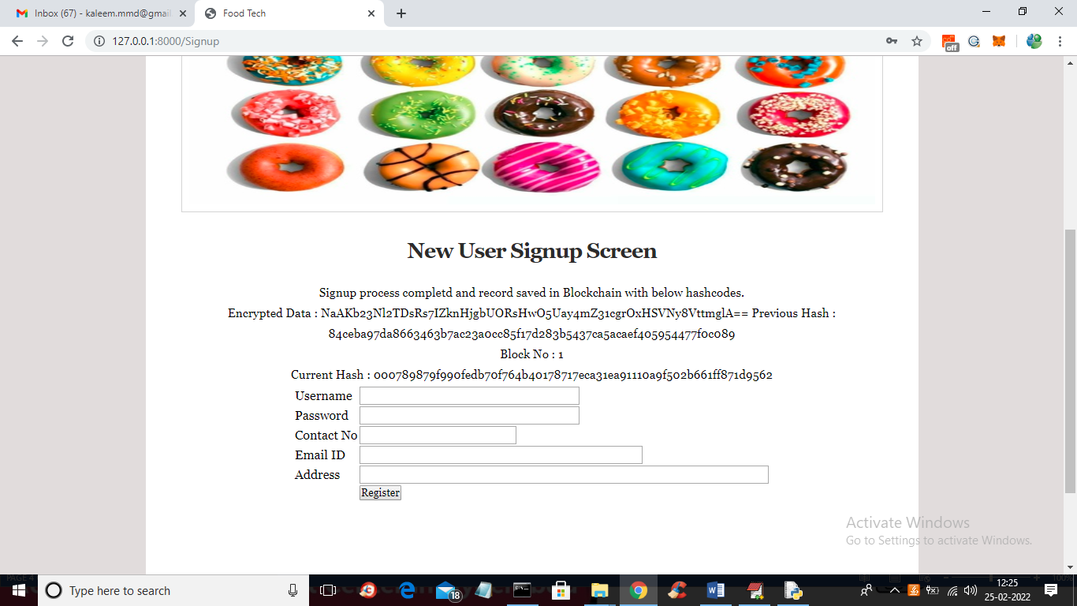

In above screen we can see signup details completed and we can see Blockchain hashcode and block number where this data is stored. Now in above screen click on ‘Admin’ link to login as admin

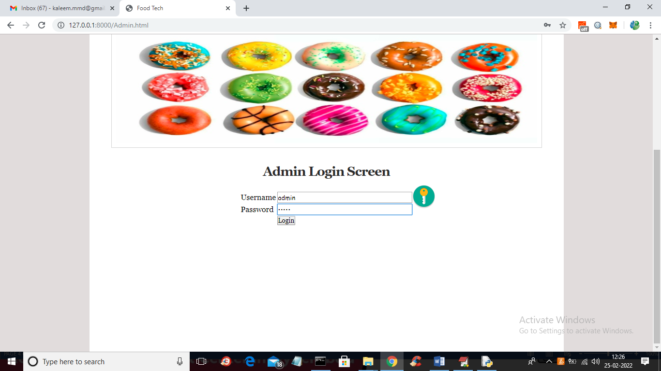

In above screen admin is login and after login will get below screen

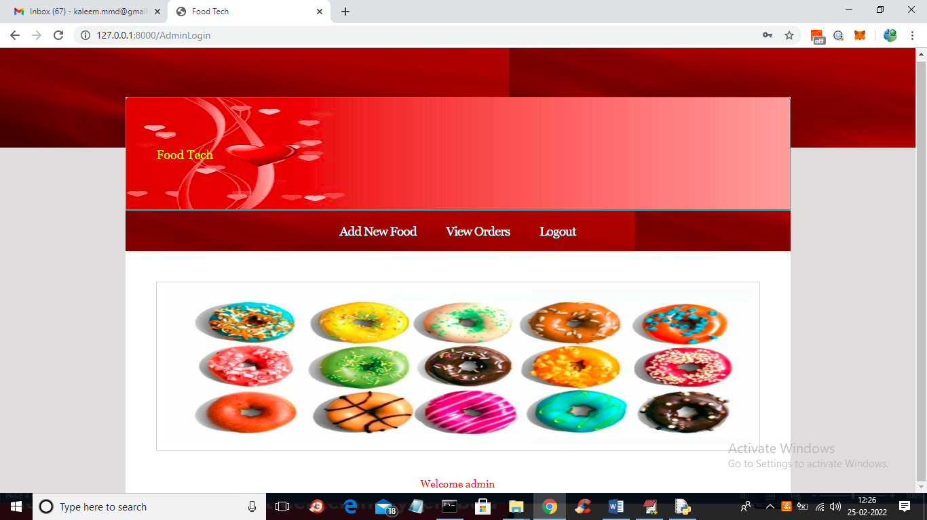

In above screen admin can click on ‘Add New Food’ link to add new food details

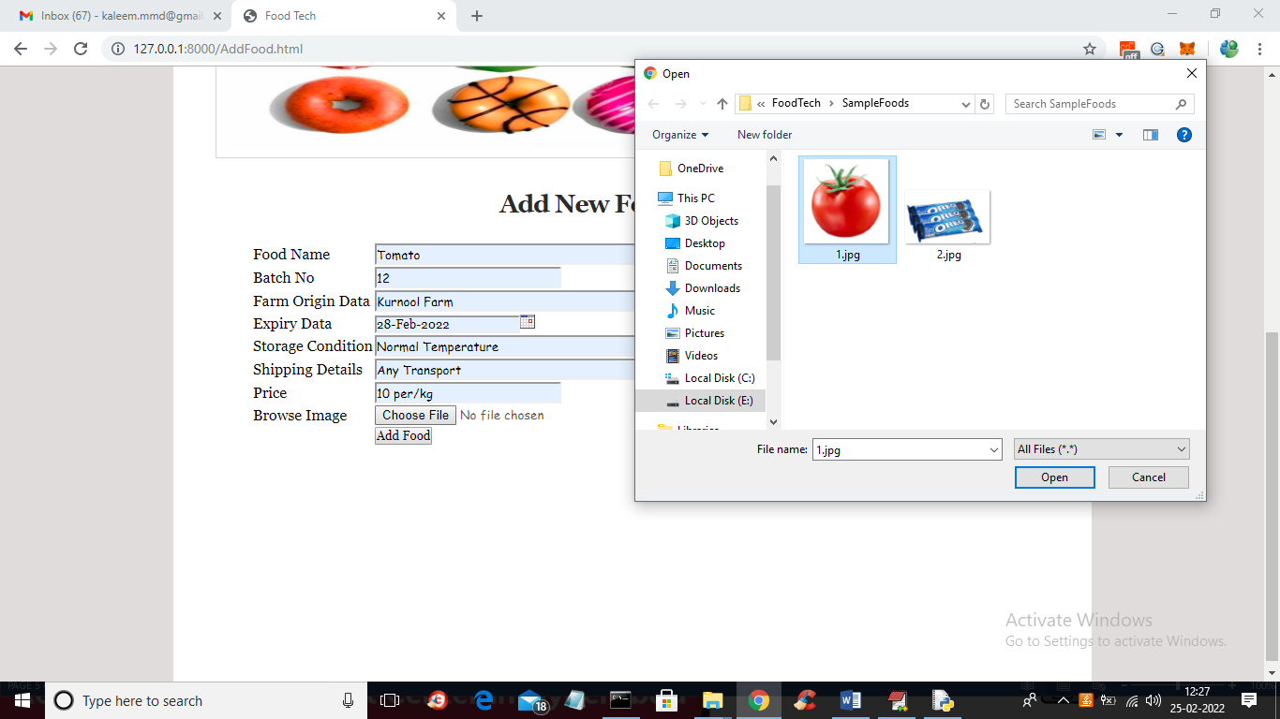

In above scree admin can new food details and upload food image and then click on ‘Add Food’ button to get below output

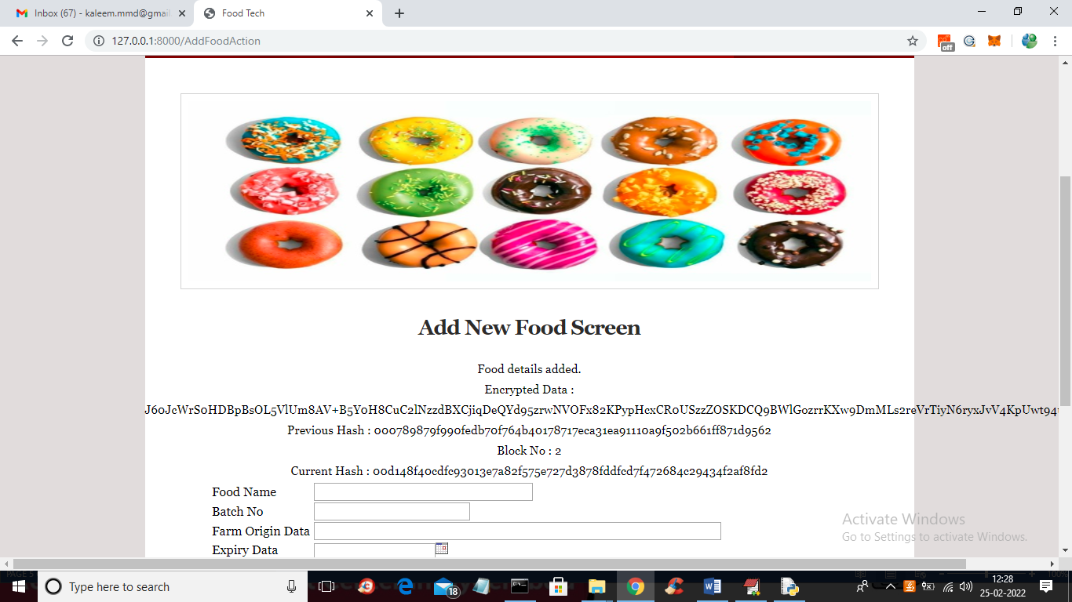

In above screen we can see hash code and block number where this details are stored and similarly you can add any number of foods and now logout and book food

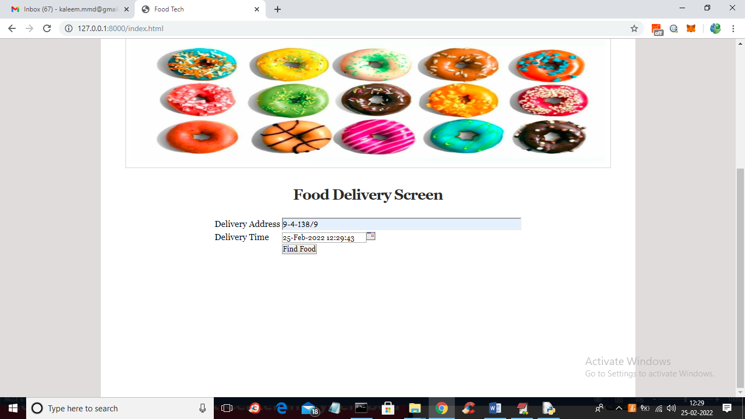

In above screen user can enter delivery address and time and then click on ‘Find Food’ button to get below screen

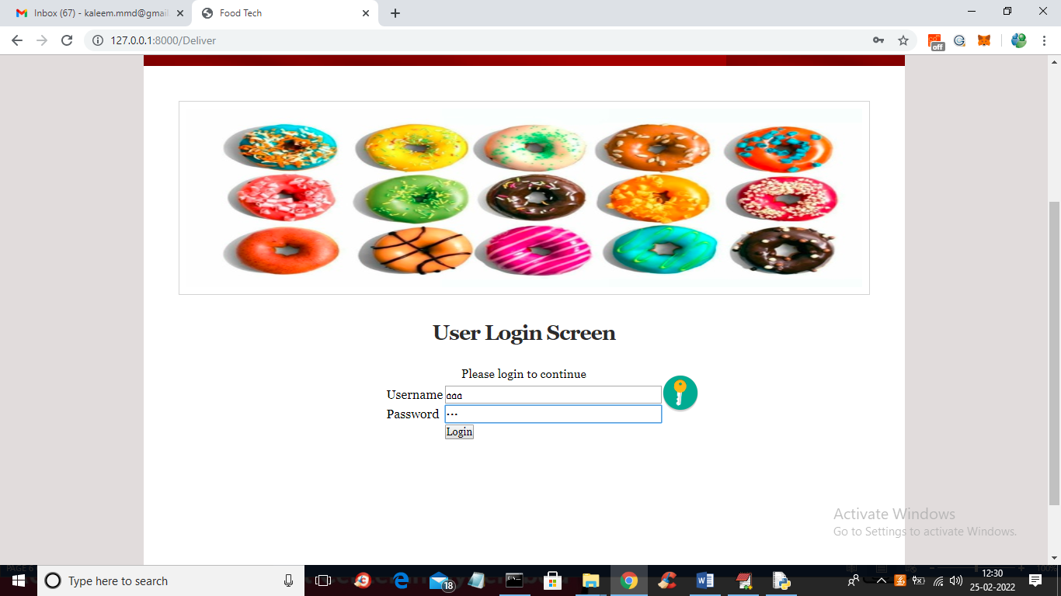

In above screen application asking user to get login first in order to continue and then press ‘Login’ button to get below screen

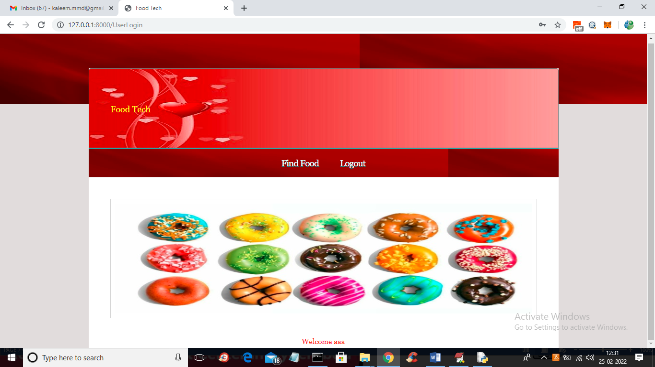

In above screen user can click on ‘Find Food’ link to get below screen

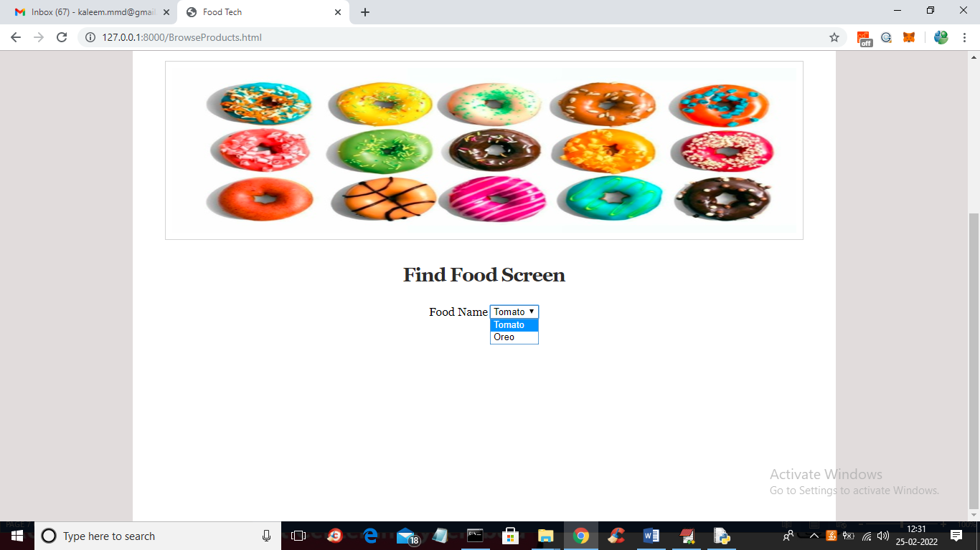

In above screen user can select desired food and then press search button to get below output

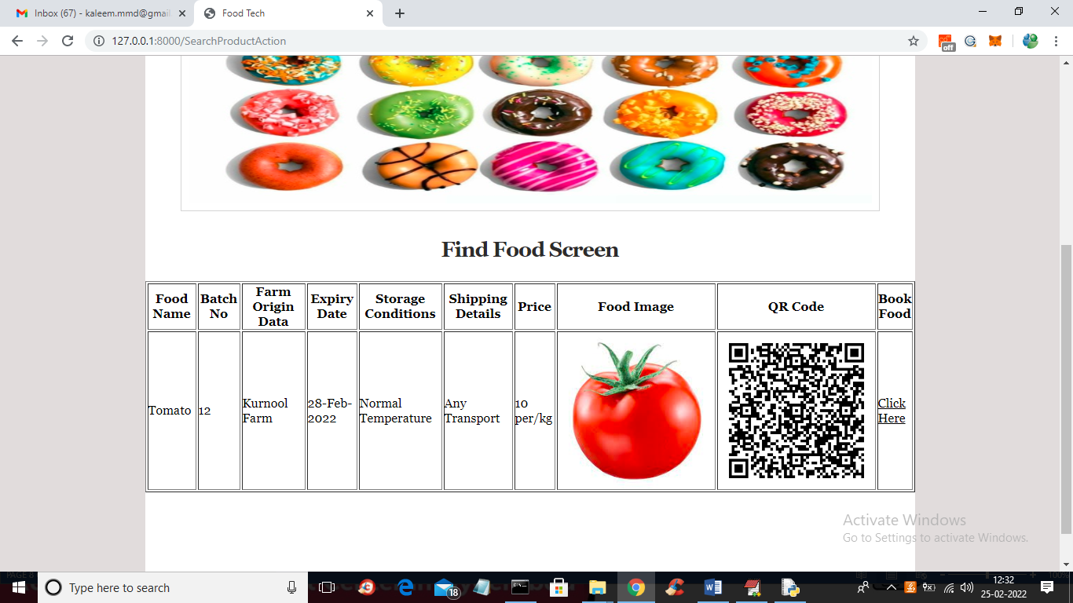

In above screen user can view all details related to food and can view QR code image also and now click on ‘Click Here’ link to confirm order and get below screen

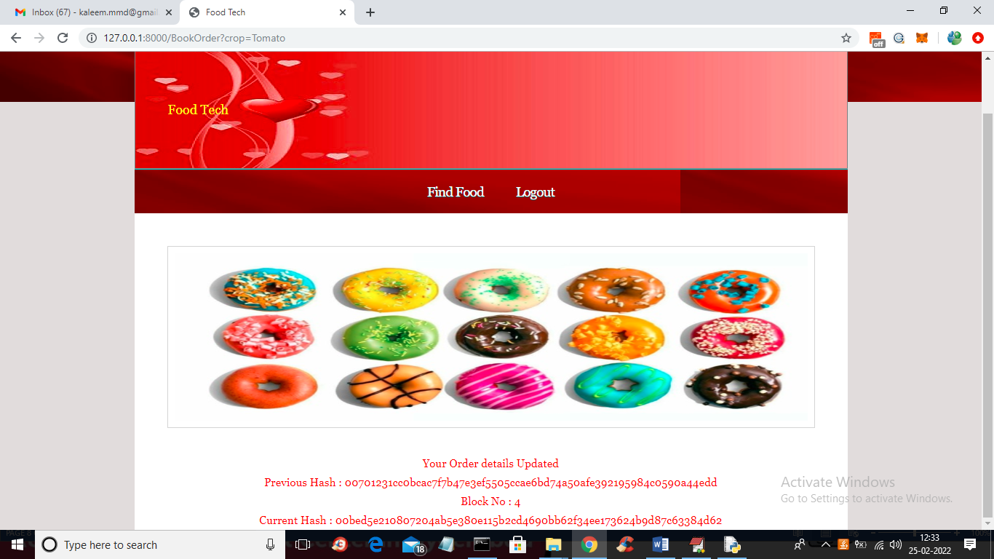

In above screen we can see order is confirmed and we can see hash code and block number where this details are stored in Blockchain and now admin can view this order to complete delivery.

Similarly admin can add any number of new foods and users can browse and book those foods